DEVELOPMENT TITLE: Canoe North Adventures Guided River Outfitting in Nahanni National Park Reserve.

Proposed development date(s): June 20 - Sep 1, 2020

DEVELOPMENT DESCRIPTION:
Many visitors accessing Nahanni National Park Reserve (Nahanni) do so as clients of commercial outfitting companies. Guided river outfitting typically begins at earliest the first week of June (more often, the second to third week of June) and, on average, run until the first week of September. They range anywhere from one to three weeks in length and include river tripping and hiking as primary activities. A commercial river outfitter must obtain a Parks Canada business licence to operate in Nahanni.
The Guidelines for Licensing of Guided River Outfitting in Nahanni and Nááts’įhch’oh National Park Reserves outline the considerations for safety and sustainability, set quotas for visitation and limit the number of licences Parks Canada issues in Nahanni National Park Reserve. There will only be 4 licences issued, one of which is reserved for an Indigenous Dehcho business. The guidelines were developed through detailed public consultations, stakeholder engagement and in consultation with cooperative management partners in Nááts’įhch’oh and Nahanni National Park Reserves.
As per the licensing guidelines and dependent on the outcome of this preliminary screening, Parks Canada is considering the issuance of a business licence to Canoe North Adventures to offer guided river outfitting services in Nahanni National Park Reserve. This business licence would allow the licensee to guide up to 4 trips in June, 4 trips in July and 6 trips in August. A maximum of 15 people (including guides) would be permitted on each guided excursion. Canoe North Adventures has indicated in their application that their trips will primarily start at Náįlįcho and end at Nahanni Butte near Highway 7. According to the Mackenzie Valley Resource Management Act (MVRMA), a Parks Canada business licence must undergo preliminary screening. This preliminary screening applies to Canoe North Adventures’ application for a business licence to conduct guided river outfitting activities in Nahanni National Park Reserve.:

Activities
- Water-based: canoeing
- Land-based: camping, day hiking, backpacking (overnight camping)
Locations (see map, Appendix 1)

WATER-BASED ACTIVITY START LOCATIONS
Island Lakes, Nahanni | Access for the South Nahanni River
Bunny Bar, Nahanni
Gahnįhthah Mįe, Nahanni
Náįlįcho, Nahanni

WATER-BASED ACTIVITY END LOCATIONS
Gahnįhthah Mįe, Nahanni | Blackstone Territorial Park, NT
Náįlįcho, Nahanni | Łı́ı́dlı̨ı̨ Kų́ę́, NT
Nahanni Butte, NT
Lindberg’s Landing, NT

WATER-BASED ACTIVITY CAMP LOCATIONS
Náįlįcho | Gahnįhthah Mįe
Glacier Lake
Random camp locations along the South Nahanni River

HIKING / BACKPACKING ROUTES (Note: all are backcountry/non-maintained routes)
South Nahanni River to Glacier Lake (multi-night) | Glacier Lake to Fairy Meadows (multi-night)
Gahnįhthah Mįe to Gahnįhthah Tufa Mounds (day) | Gahnįhthah Portage and Campground (day)
Sunblood Mountain (day) | Marengo Creek (day)
Pulpit Rock and Gate Viewpoint (day) | Painted Canyon (day)
Scow Creek (day) | Lafferty’s Creek (day)
Other exploratory day hike routes along river corridors

Mitigations
Canoe North Adventures will follow best practices for leave-no-trace camping and will adhere to the mitigations described in the Parks Canada Best Management Practice for Commercially Guided Eco-tourism Activities in Nahanni and Nááts'įhch'oh National Park Reserve of Canada. This document is available upon request from Parks Canada staff at Nahanni.

Appendix 1
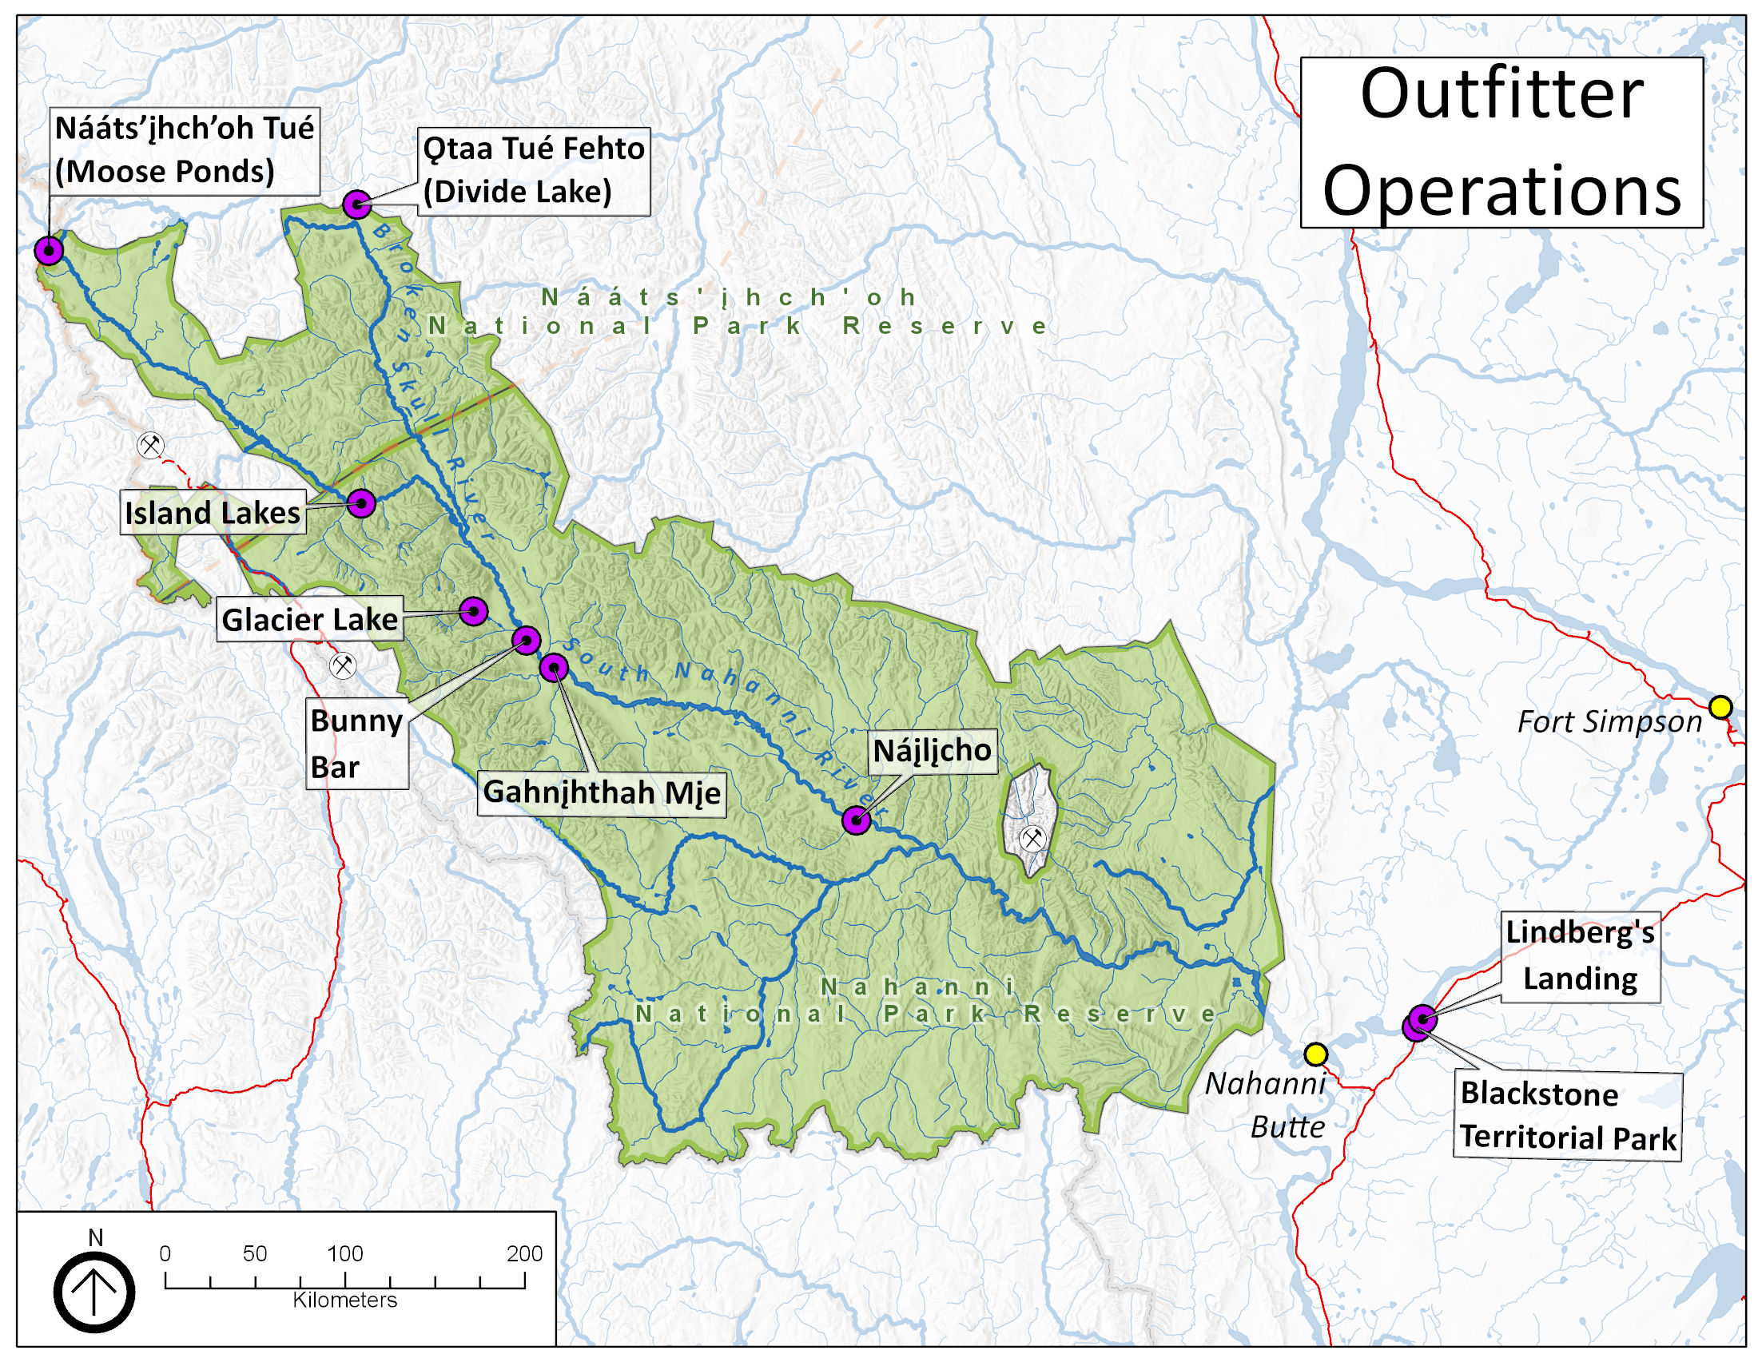

Appendix 2 - Distribution List
Organization | Contact
Mackenzie Valley Environmental Impact Review Board | preliminaryscreening@reviewboard.ca
Mackenzie Valley Land and Water Board | jpotten@mvlwb.com; tyree@mvlwb.com
Dehcho First Nations | jackson_mcdermott@dehcho.org; dahti_tsetso@dehcho.org
Chief Jerry Antoine  Liidlii Kue First Nation | chief@liidliikue.com
Chief Gladys Norwegian  JMR First Nation | chief@jmrfn.com
Chief Darrell Betsaka  Nahanni Butte Dene Band | chief.betsaka@gmail.com
Chief Joachim Bonnetrouge  Deh Gah Gotie First Nation | chief@dehgahgotie.ca
Chief Lloyd Chicot  Ka’a'gee Tu First Nation | kaageetu_chief@northwestel.net
Chief Dolphus Jumbo  Sambaa K’e Dene Band | chief@sambaakefn.com
Chief Darcy E. Moses  Pehdzeh Ki First Nation | pkfnlands@outlook.com
Chief Courtney Cayen (via Misty Ireland, Lands Dept) West Point First Nation | land@wpfn.ca
President Clifford McLeod  Fort Providence Métis Nation | fpmcpres@northwestel.net
President Marie Lafferty  Fort Simpson Métis Local | metisnation52@ northwestel.net
Keyna Norwegian | eaglefirelogistics@gmail.com
Air Tindi | info@airtindi.com
Alpine Aviation | alpineaviation@gmail.com
Black Sheep Aviation & Cattle Co. Ltd. | info@flyblacksheep.ca
Great Slave Helicopters 2018 | fortsimpson@gsheli.com
Kluane Airways Ltd | info@kluaneairways.com
Liard Air Ltd | info@nrlodge.com
Northern Rockies Air Charter Ltd. | info@scooplake.com
North-Wright Airways Ltd | ops@north-wrightairways.com
Simpson Air 1981 Ltd | simpsonair@northwestel.net
Solitude Excursions Ltd | hike@helihikenahanni.com
South Nahanni Airways | info@southnahanniairways.ca;  charters@southnahanniairways.ca
Summit Air and Summit Helicopters | peter.rice@summithelicopters.ca  info@flysummitair.com
Trans North Turbo Air Limited | dpachiorka@tntaheli.com
Tundra Helicopters | tundrahelicopters@hotmail.com
Black Feather  The Wilderness Adventure Company | info@blackfeather.com
Nahanni Wilderness Adventures | adventures@nahanniwild.com
Jennifer Thistle, Acting Regional Superintendent, Dehcho Industry, Tourism and Investment, Government of the Northwest Territories | Jennifer_Thistle@gov.nt.ca
Douglas Dillon (Aboriginal Tourism Development Officer, Industry, Tourism and Investment - Tourism and Parks Division Government of the Northwest Territories) | Douglas_Dillon@gov.nt.ca
Cathie Bolstad (Executive Director, NWT Tourism) | executive@spectacularnwt.com
CPAWS, NWT Chapter | nwtadmin@cpaws.org
Canoe North Adventures | info@canoenorthadventures.com
Jackpine Paddle | info@jackpinepaddle.com
Tulita Land/Financial Corporation | president@tulitalandcorp.ca  executivedirector@tulitalandcorp.ca
Fort Norman Metis Land Corporation | rockynorwegian@gmail.com  execdirno60@gmail.com
Norman Wells Land Corporation | hci2@theedgenw.ca
Tulita Renewable Resources Council | trrc@northwestel.net
Norman Wells Renewable Resources Council | sahtuapple@hotmail.com  nwrrc@nwlc.ca
Tulita District Land Corporation | hci2@theedgenw.ca  district@allstream.net
Tulita Dene Band | tdbchief@live.ca  band_manager@tulitadeneband.com
Hamlet of Tulita | rockynorwegian@gmail.com  SAO@hamletoftulita.ca
Town of Norman Wells | Mayor_Frank_Pope@normanwells.com;  SeniorAdministrativeOfficer@normanwells.com

