
EA0506-003 Ur Energy Uranium Exploration Screech Lake

Work Plan

INTRODUCTION
On May 3, 2005 the Mackenzie Valley Land and Water Board (MVLWB) referred a proposed mineral exploration program for uranium at Screech Lake east of Great Slave Lake (see map in appendix 1) to environmental assessment, pursuant to section 125 of the Mackenzie Valley Resource Management Act (MVRMA). The MVLWB cited a “likelihood that the proposed development might be cause of public concern” as the reason for referral. The MVLWB concluded that there is “no likelihood that the proposed development might have a significant adverse impact on the environment”.
This Environmental Assessment (EA) is subject to the requirements of Part 5 of the MVRMA. It is also subject to the MVEIRB’s Environmental Impact Assessment Guidelines and the MVEIRB’s Rules of Procedure. Please note that the Rules of Procedure have recently been revised. These documents can be accessed at http://www.mveirb.nt.ca/HTML/MVGuides/MVdocs.asp.
The definitions of MVRMA section 111 apply in this document and throughout the EA. Terms not defined in the MVRMA are used in their general sense and do not imply specific activities or standards that may be associated with the term in other jurisdictions.

EA Process
This EA will be conducted in a fashion similar to that of EA03-007 Mackenzie Gas Project, i.e. in potentially two phases. Phase one will consist of a public hearing that will:
- clarify the scope of the development;
- clarify the scope of the assessment;
- gauge the level of public concern and identify its sources; and
- provide the Board with information to address the factors it must consider in every EA.
Following the hearing the Board will decide whether sufficient evidence has been brought before it to make a decision. If the Board determines it has sufficient information it will close the public record, enter its deliberations, and issue its report of environmental assessment without entering phase two.
In the event that the hearing and/or prior submissions do not provide the Board with sufficient information, the Board will enter a second phase of the EA. The second phase may consist of an information request process only or may consist of a full EA process as described in the EIA Guidelines, including a terms of reference, a developers assessment report, information requests, and technical analysis reports.
This work plan only provides details for phase one. Phase two, if necessary, will be defined based on the outcome of phase one.

Scope

Scope of Development
The MVEIRB has set the scope of the development to be that of the development described in Land Use Permit application MV2005C0007. The application can be accessed from the MVLWB’s public registry at http://www.mvlwb.com/scr/search.php?landid=%20474.
The proposed development involves a camp, fuel storage, geological mapping, prospecting, and diamond drilling. The development is to be carried out during summer and fall.
The Board may adjust the scope of development based on evidence submitted by the developer or by registered parties prior to or during the public hearing.

Scope of Assessment
During phase one the MVEIRB will consider the following factors pursuant to MVRMA s. 117(2):
- the impact of the development on the environment, including malfunctions or accidents and any cumulative impact that is likely to result;
- the significance of any such impact;
- any comments submitted by members of the public;
- the imposition of mitigation measures, where an impact is found; and
- any other matter including available alternatives to the development.
The Board will refine the scope of assessment, including temporal and spatial boundaries based on evidence submitted prior to or during the public hearing.

ROLES AND RESPONSIBILITIES

Review Board
The Review Board is required to undertake the following in relation to this EA:
- Conduct the EA in accordance with ss.126(1) of the MVRMA;
- Determine the scope of the development, in accordance with ss.117 (1) of the MVRMA;
- Consider environmental assessment factors in accordance with ss.117 (2) of the MVRMA;
- Make a determination regarding the environmental impacts or public concern about the development, in accordance with ss.128 (1) of the MVRMA;
- Report to the Federal Minister in accordance with ss.128 (2) of the MVRMA; and,
- Identify areas and extent of effects, within or outside the Mackenzie Valley in which the development is likely to have a significant adverse impact or be a cause of significant public concern, in accordance with ss.128 (4) of the MVRMA.

Review Board Staff
The Review Board’s Executive Director and staff are the primary contacts for the developer, government bodies (federal, territorial and municipal), non-government organizations (NGOs), aboriginal groups, expert advisors (experts contracted directly by the Review Board), the public and other interested parties. This does not limit or preclude the Developer from contacting other parties during the EA process. The Review Board may choose to hire expert advisors to provide technical expertise on specific aspects of the EA.
All related correspondence should be directed to the Environmental Assessment Officer for the EA:
Martin Haefele
Tel: (867) 766-7053
Fax: (867) 766-7074
e-mail: mhaefele@mveirb.nt.ca
P.O. Box 938 (5102 50th Ave) Yellowknife, NT X1A 2N7

Developer
The developer is expected to respond in a suitable and timely manner to directions and requests issued by the Review Board. During phase one of the EA such requests may include the provision of a detailed development description, presence and participation in a pre-hearing conference and a hearing, and the production of public information material (e.g. a presentation). In phase two, if required, additional requests may include responses to information requests, translation of documents, and production of a developer’s assessment report. The developer may present additional information at any time to the Review Board beyond what was requested during the EA process.
The Review Board encourages the developer to continue consulting all potentially affected communities and organizations during the EA process.

Parties
The MVEIRB’s Rules of Procedure no longer distinguish between directly affected parties and interveners. All parties to the EA have the same rights and responsibilities. Party standing does not confer any legal status beyond the Review Board’s proceeding. Parties may present information at any time during the EA and may be given an opportunity to submit information requests for Board approval if phase two is entered. Parties may also be asked to provide the Board with technical analysis reports.

EA Phase 1 Schedule
The following schedule applies to phase one of this EA.
Timeframe | Activity/Milestone
May 20 to June 3 | Developer/LKDFN to submit additional information
May 20 to June 3 | Parties to EA to identify themselves
June 17 | Pre-hearing conference (teleconference)
June 29 | Community Hearing in Lutsel K’e
July 19 | Board decision whether to enter phase two of EA
August 19 | Issuance of decision and report of environmental assessment
All parties will be informed of the exact time and location for the hearing and the pre-hearing conference as soon as possible. The pre-hearing conference will be conducted via telephone conferencing; parties present in Yellowknife that day are encouraged to attend in person. The public hearing will be held in Lutsel K’e and will be conducted as ‘community hearing’ under the MVEIRB’s Rules of Procedure.

Identification of Parties
The Board is asking individuals and organizations to request party standing by June 10, 2005 using the form in appendix 2. Party status may be granted at any time during the proceedings. Parties identifying themselves after June 10, 2005 should be aware that a need to review the public record will not be accepted as reason for extending timelines.

Written Submissions
All parties, as well as the public, are invited to submit evidence that, in their opinion, will assist the Board in conducting this environmental assessment. In particular, the Board is seeking any evidence any party may have that addresses the factors outlined in section 3.2 of this work plan.
Written submissions will be placed on the public record. Upon special request the Board may consider confidential submissions. Parties who do not wish to have their submission put on the public record must contact board staff prior to making a submission. The Board will decide on a case by case basis on the merits of a request for confidentiality and if it will receive and consider such a submission as per its Rules of Procedure.
Submissions should be in a format that is easily accessible to all EA participants. The Review Board prefers documents to be submitted digitally in either Word or PDF format. However, hardcopy, hand delivered or via courier, as well as fax transmissions is acceptable as long as the documents can be reproduced via photocopier in a clearly legible manner. For regular mail the date the submission is received at the Review Board’s office is considered to be the submission date. The Board will not consider any submission after the closing of the public record.
Oversized items or items that are difficult to reproduce, such as colour maps, should be submitted digitally, and/or hardcopy in sufficient quantities to be distributed to those parties with limited access to computer technology. Please contact the Review Board’s staff for the quantities required.

Appendix 1 Overview Map
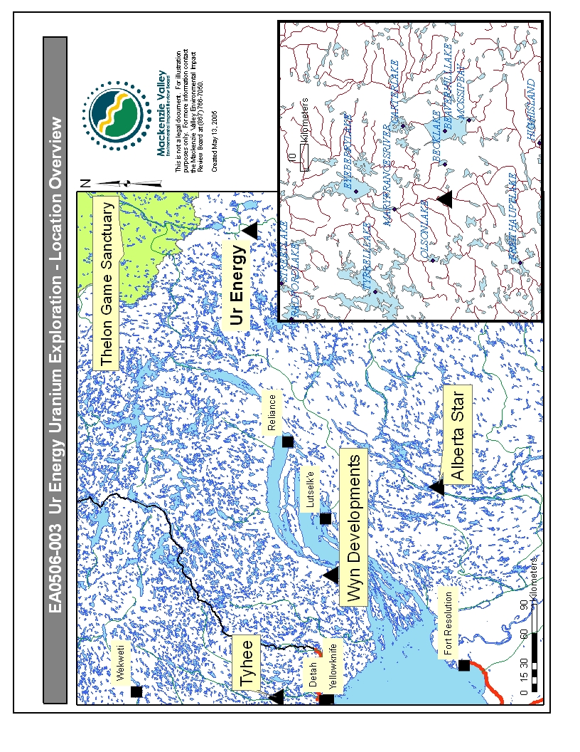
Appendix 2 Party Status Request Form
 | Mackenzie Valley Environmental Impact Review Board  FORM 1 Request for Party Status

Name of Organization:
Name of Proceeding:

Reasons for requesting Party Status in these proceedings.
Participation:
Please describe how you or your organization intends to participate in this proceeding, such as what information, witnesses, or presentations you plan to submit.
If you represent a Responsible Minister or Responsible Authority please state which one.
List the licences, permits or authorizations issued by your organization relevant to this proceeding.
Contact Information:
Please confirm the organization's contact information and the name of the primary contact person for Board correspondence purposes.
Dated at , Northwest Territories, on (MM/DD/YY) _______________ .

(Signature of Party's Representative)

