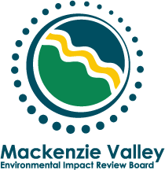
EA0506-007 Paramount Significant Discovery Licence 8, 2D Geophysical Program (SDL8)

Work Plan

INTRODUCTION
On November 23, 2005 the Department of Indian Affairs and Northern Development (DIAND) referred a proposed geophysical exploration program for oil and gas on Paramount Resources Ltd’s (Paramount) Significant Discovery 8 to environmental assessment, pursuant to section 125 of the Mackenzie Valley Resource Management Act (MVRMA).. The proposed development is located between the Cameron Hills and Highway 1, just north of the NWT/Alberta border. (see map in appendix 1) DIAND referred the development on behalf of the Ka’a’Gee Tu First Nation. The Ka’a’Gee Tu First Nation is of the opinion that the proposed project could have an adverse impact on the environment of the Ka’a’ Gee Tu’s traditional territory.
This Environmental Assessment (EA) is subject to Part 5 of the MVRMA, as well as the MVEIRB’s Environmental Impact Assessment Guidelines and the MVEIRB’s Rules of Procedure. These documents can be accessed at http://www.mveirb.nt.ca/HTML/MVGuides/MVdocs.asp.
The definitions of MVRMA section 111 apply in this document and throughout the EA. Terms not defined in the MVRMA are used in their general sense and do not imply specific activities or standards that may be associated with the term in other jurisdictions.

Scope

Scope of Development
The Review Board determines the scope of the development to be as described in Paramount’s application for a land use permit to the Mackenzie Valley Land and Water Board of September 2, 2005 (MV2005B0021).
The application can be accessed and downloaded from the Land and Water Board’s web site at:
http://www.mvlwb.com/pdf/2005Land/MV2005B0021/MV2005B0021-LtrforReview-Paramount-2DSeismic-CameronHills-Sep05.pdf
Hard copies will be mailed to parties outside of Yellowknife on request.

Scope of Assessment
The Review Board reviewed the submissions from government agencies and aboriginal groups to the Mackenzie Valley Land and Water Board’s preliminary screening process, as well as the public record for EA03-005 for Paramount’s operation in nearby Cameron Hills. Based on this review, and subject to additional issues identified by the Review Board at or following the community hearing, the Review Board determines that the scope of this environmental assessment includes:
- effects on woodland caribou, including cumulative effects; and
- effects on wildlife harvesting, including cumulative effects.
The Review Board is aware that:
- similar developments have taken place in close proximity within and outside the Mackenzie Valley;
- woodland caribou ranges cross the NWT/Alberta border; and
- traditional harvesting in the project area may not be limited to residents of the Mackenzie Valley.
Consequently, the geographical scope of this environmental assessment is set to include areas within or outside the Mackenzie Valley that:
- are frequented by caribou that may be affected by the proposed development, and
- include those communities that have traditionally harvested wildlife in the SDL8 area.
Pursuant to section 140(1) the Review Board has notified the relevant authority in Alberta.

ROLES AND RESPONSIBILITIES

Review Board
The Review Board is required to undertake the following in relation to this EA:
- Conduct the EA in accordance with ss.126(1) of the MVRMA;
- Determine the scope of the development, in accordance with ss.117 (1) of the MVRMA;
- Consider environmental assessment factors in accordance with ss.117 (2) of the MVRMA;
- Make a determination regarding the environmental impacts or public concern about the development, in accordance with ss.128 (1) of the MVRMA;
- Report to the Federal Minister in accordance with ss.128 (2) of the MVRMA; and,
- Identify areas and extent of effects, within or outside the Mackenzie Valley in which the development is likely to have a significant adverse impact or be a cause of significant public concern, in accordance with ss.128 (4) of the MVRMA.

Review Board Staff
The Review Board’s Executive Director and staff are the primary contacts for the developer, government bodies (federal, territorial and municipal), non-government organizations (NGOs), aboriginal groups, expert advisors, the public and other interested parties. This does not limit or preclude the Developer from contacting other parties during the EA process. The Review Board may choose to hire expert advisors to provide technical expertise on specific aspects of the EA.
All related correspondence should be directed to the Environmental Assessment Officer for the EA:
Martin Haefele
Tel: (867) 766-7053
Fax: (867) 766-7074
e-mail: mhaefele@mveirb.nt.ca
P.O. Box 938 (5102 50th Ave) Yellowknife, NT X1A 2N7

Developer
The developer is expected to respond in a suitable and timely manner to directions and requests issued by the Review Board. Such requests may include presence and participation in a hearing and technical sessions, responding to information requests and the production of public information material (e.g. a presentation). The developer may present additional information at any time to the Review Board beyond what was requested during the EA process.
The Review Board encourages the developer to continue consulting all potentially affected communities and organizations during the environmental assessment process.

Parties
Organizations and individuals who want to play an active role in this assessment should fill out the party identification form in appendix B and return it to the MVEIRB by January 31, 2006. Party standing may be requested and granted at any time during the proceeding. However, the Review Board will not extend timelines to accommodate late joining parties.
Party standing does not confer any legal status beyond the Review Board’s proceeding. Parties may present information at any time during the environmental assessment and may be given an opportunity to submit information requests for Board approval. Parties may also be asked to provide the Board with technical analysis reports.

Environmental assessment Schedule
Considering the limited scope of the assessment and the availability of a detailed development description, which includes a discussion of possible environmental effects, the Review Board will conduct this environmental assessment as follows:
Timeframe | Activity/Milestone
December 2005 | Work Plan issued
January 2006 | Party Identification
Mid to late February 2006 | Community Hearing
March/April 2006 | Information Requests round 1
Late April/early May 2006 | Technical Sessions (or Information Requests round 2)
June/July 2006 | Technical Reports (if required) and Closure of Public Record
July/August 2006 | Board Deliberation and Decision
The community hearing is currently planned to be held in Kakisa. The exact date and location are to be determined and will be announced in January 2006.
The work plan and schedule are subject to change and will be adjusted by the Review Board depending on information needs identified throughout the proceedings.

Written Submissions
All parties, as well as the public, are invited to submit evidence that, in their opinion, will assist the Board in conducting this environmental assessment. In particular, the Board is seeking evidence any party may have that addresses the factors outlined in section 2.2 of this work plan.
Written submissions will be placed on the public record. Upon special request the Board may consider confidential submissions. Parties who do not wish to have their submission put on the public record must contact board staff prior to making a submission. The Board will decide on a case by case basis on the merits of a request for confidentiality and if it will receive and consider such a submission as per its Rules of Procedure.
Submissions should be in a format that is easily accessible to all EA participants. The Review Board prefers documents to be submitted digitally in either Word or PDF format. However, hardcopy, hand delivered or via courier, as well as fax transmission is acceptable as long as the documents can be reproduced via photocopier in a clearly legible manner. For regular mail the date the document is received at the Review Board’s office is considered to be the submission date. The Board will not consider any submission after the closing of the public record.
Oversized items or items that are difficult to reproduce, such as colour maps, should be submitted digitally, and/or hardcopy in sufficient quantities to be distributed to those parties with limited access to computer technology. Please contact the Review Board’s staff for the quantities required.

Appendix 1 Overview Map
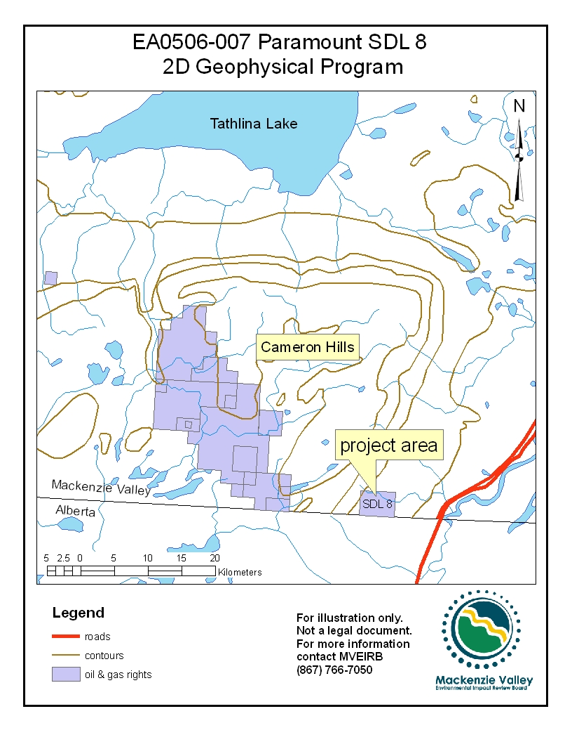

Appendix 2 Party Status Request Form
 | Mackenzie Valley Environmental Impact Review Board  FORM 1 Request for Party Status

Name of Organization:
Name of Proceeding:

Reasons for requesting Party Status in these proceedings.
Participation:
Please describe how you or your organization intends to participate in this proceeding, such as what information, witnesses, or presentations you plan to submit.
If you represent a Responsible Minister or Responsible Authority please state which one.
List the licences, permits or authorizations issued by your organization relevant to this proceeding.
Contact Information:
Please confirm the organization's contact information and the name of the primary contact person for Board correspondence purposes.
Dated at , Northwest Territories, on (MM/DD/YY) _______________ .

(Signature of Party's Representative)

